Joshua Catoe

06/19/18

Assignment 03

Schema:

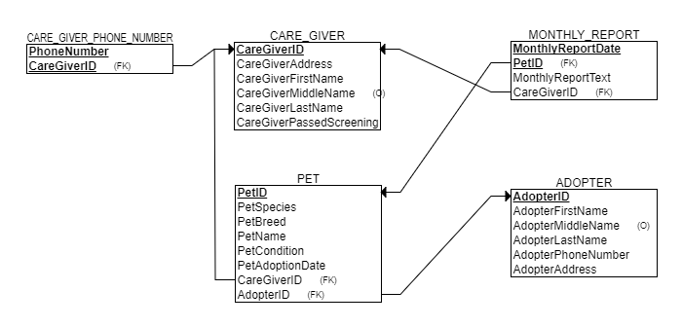

Tables:

CARE_GIVER

|  |  |  |  |  |  |
| --- | --- | --- | --- | --- | --- |
| CareGiverID | CareGiverAddress | CareGiverFirstName | CareGiverMiddlename | CareGiverLastName | CareGiverPassedScreening |
| C-01 | 666 Elm St. | John |  | Stevens | Yes |
| C-02 | 719 Park Place Ave. | Jane | Elizabeth | Smith | Yes |
| C-03 | 501 Rocky Rd. | Joe |  | Schmoe | Yes |

CARE_GIVER_PHONE_NUMBER

|  |  |
| --- | --- |
| PhoneNumber | CaregiverID |
| (843) 292-0178 | C-01 |
| (843) 555-0567 | C-02 |
| (843) 626-4365 | C-03 |

MONTHLY_REPORT

|  |  |  |  |
| --- | --- | --- | --- |
| MonthlyReportDate | PetID | MonthlyReportText | CareGiverID |
| 15 December, 2017 | P-001 | Luna is in great condition… | C-03 |
| 5 March, 2018 | P-002 | …all over the floor… | C-01 |
| 18 April, 2018 | P-003 | …snuck out of his cage. | C-02 |

PET

|  |  |  |  |  |  |  |  |
| --- | --- | --- | --- | --- | --- | --- | --- |
| PetID | PetSpecies | PetBreed | PetName | PetCondition | PetAdoptionDate | CareGiverID | AdopterID |
| P-001 | Cat | Siamese | Luna | Good | 01 January, 2018 | C-03 | A-001 |
| P-002 | Dog | Poodle | Beverly | Sick | 16 March, 2018 | C-01 | A-003 |
| P-003 | Snake | Python | Jeff | Good | 31 May, 2018 | C-02 | A-002 |

ADOPTER

|  |  |  |  |  |  |
| --- | --- | --- | --- | --- | --- |
| AdopterID | AdopterFirstName | AdopterMiddleName | AdopterLastName | AdopterPhoneNumber | AdopterAddress |
| A-001 | Jonathan | Joseph | Edwards | (843) 777-0625 | 1587 Sesame St. |
| A-002 | Larry |  | Johnson | (843) 654-9987 | 504 Mountain Way |
| A-003 | Brittany | Chelsea | Simpson | (843) 056-1269 | 1177 Baltic Ave. |